Yoqubova Himoyatxon module 1. Class 3

Task 1: Find 3 Real AI/ML Applications in Uzbekistan
Artificial Intelligence (AI) is widely used in different sectors in Uzbekistan.
The first example is the Uzum platform. This is an e-commerce system that recommends products to users. The system works based on users’ search history, clicks, and purchases. In this way, it provides personalized recommendations for each user.
The second example is the Payme application. It is a financial service that includes a fraud detection system. The system analyzes transactions and identifies suspicious activities to ensure security.
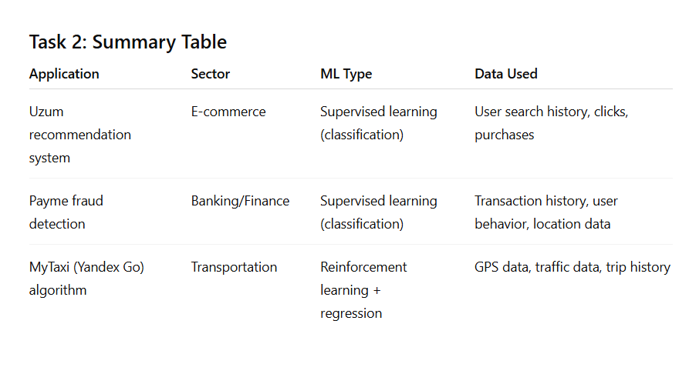
The third example is MyTaxi (Yandex Go). This transportation service uses AI to select routes and calculate prices. The system considers traffic conditions, distance, and demand to provide the most optimal option.

Task 3: Explanation Paragraphs
1. Uzum recommendation system
The Uzum platform recommends products to users based on their interests. This system likely uses supervised learning because it predicts user preferences based on past behavior. The model is trained using user data such as searches, clicks, and purchases. Based on this information, the system learns which products to recommend. This is considered classification because it predicts what a user may like.
2. Payme fraud detection
The Payme application uses AI to detect fraudulent activities. This system is based on supervised learning (classification), as it classifies transactions as either normal or suspicious. The model is trained on historical transaction data, especially labeled fraud cases. For example, unusual transaction amounts or logins from different locations can be detected. This helps prevent financial risks.
3. MyTaxi (Yandex Go) algorithm
MyTaxi (Yandex Go) uses AI to determine routes and pricing. This system combines reinforcement learning and regression. It makes decisions in real time based on traffic, distance, and demand. The model learns from GPS data, traffic conditions, and previous trips. For example, it may choose a faster route during traffic or adjust pricing based on demand. This system continuously improves over time.

